**AP Lab 1**

**Submitted By: Daud Nasir Cheema (209563)**

**Task 2:**

var http = require('http');

http.createServer(function (req, res) {

res.writeHead(200, {'Content-Type': 'text/plain'});

res.end('Hello World\n');

}).listen(8080);

**Output:**

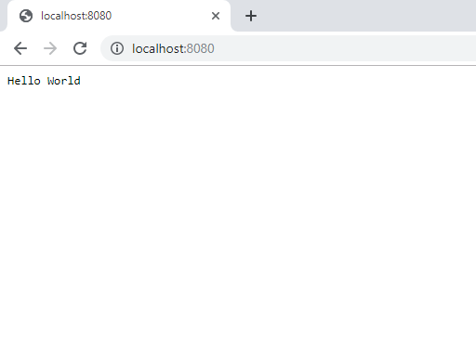

**Task 3:**

exports.returnDate = function(){

return Date();

}

**Task 4:**

var http = require('http');

var mod = require("./myfirstmodule.js");

http.createServer(function (req, res) {

res.writeHead(200, {'Content-Type': 'text/plain'});

res.end("Date and Time: " + mod.returnDate());

}).listen(8080);

**Output:**

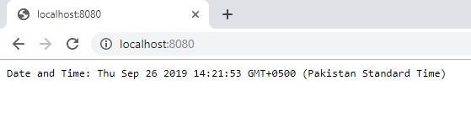

**Task 5:**

var http = require('http');

http.createServer(function (req, res) {

res.writeHead(200, {'Content-Type': 'text/plain'});

res.end("Server running on port 8080");

}).listen(8080);

**Output:**

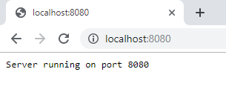

**Task 6:**

var http = require('http');

http.createServer(function (req, res) {

res.writeHead(200, {'Content-Type': 'text/plain'});

res.end("write head, status 200, content type: plain");

}).listen(8080);

**Output:**

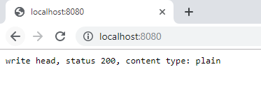

**Task 7:**

var http = require('http');

var fs = require("fs");

http.createServer(function (req, res) {

fs.readFile("myhtml.html", function(err, data){

if(err) throw err;

res.writeHead(200, {'Content-Type': 'text/html'});

res.write(data);

res.end();

});

}).listen(8080);

**Output:**

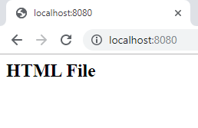

**Task 8:**

var http = require('http');

var fs = require("fs");

http.createServer(function (req, res) {

fs.appendFile("file1.txt", "This is file 1 created by append!", function(err){

if(err) throw err;

});

fs.open("file2.txt", "w", function(err, file){

if(err) throw err;

});

fs.writeFile("file3.txt", "This is file 3 create by writeFile!", function(err){

if(err) throw err;

});

res.end();

}).listen(8080);

**Output:**

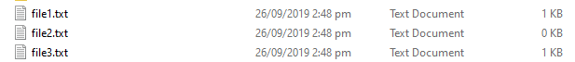

**Task 9:**

var fs = require("fs");

fs.appendFile("file1.txt", " This is my text", function(err){

if(err) throw err;

});

**Output:**

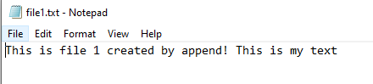

**Task 10:**

var fs = require("fs");

fs.writeFile("file1.txt", "I have replaced text!", function(err){

if(err) throw err;

});

**Output:**

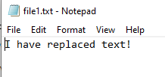

**Task 11:**

var fs = require("fs");

fs.unlink("file2.txt", function(err){

if(err) throw err;

});

**Output:**



**Task 12:**

var fs = require("fs");

fs.rename("file3.txt", "new name of file 3.txt",function(err){

if(err) throw err;

});

**Output:**

